**PARKING MANAGEMENT SYSTEM.**

**Project by-**

Uma Shankar Bhagat

Pradnya Bhavsar

**Use Case Diagram:**

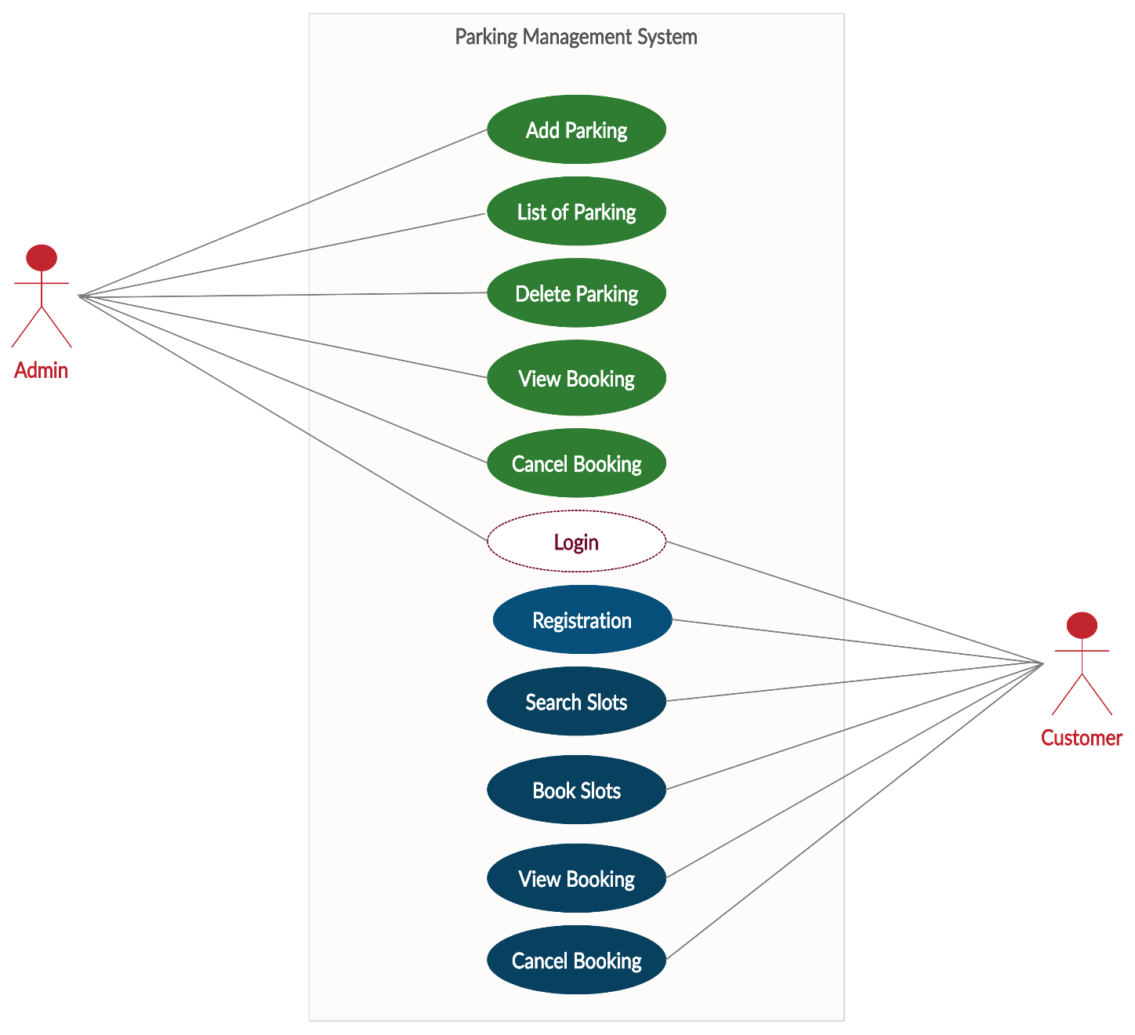

**Micro service Division:**

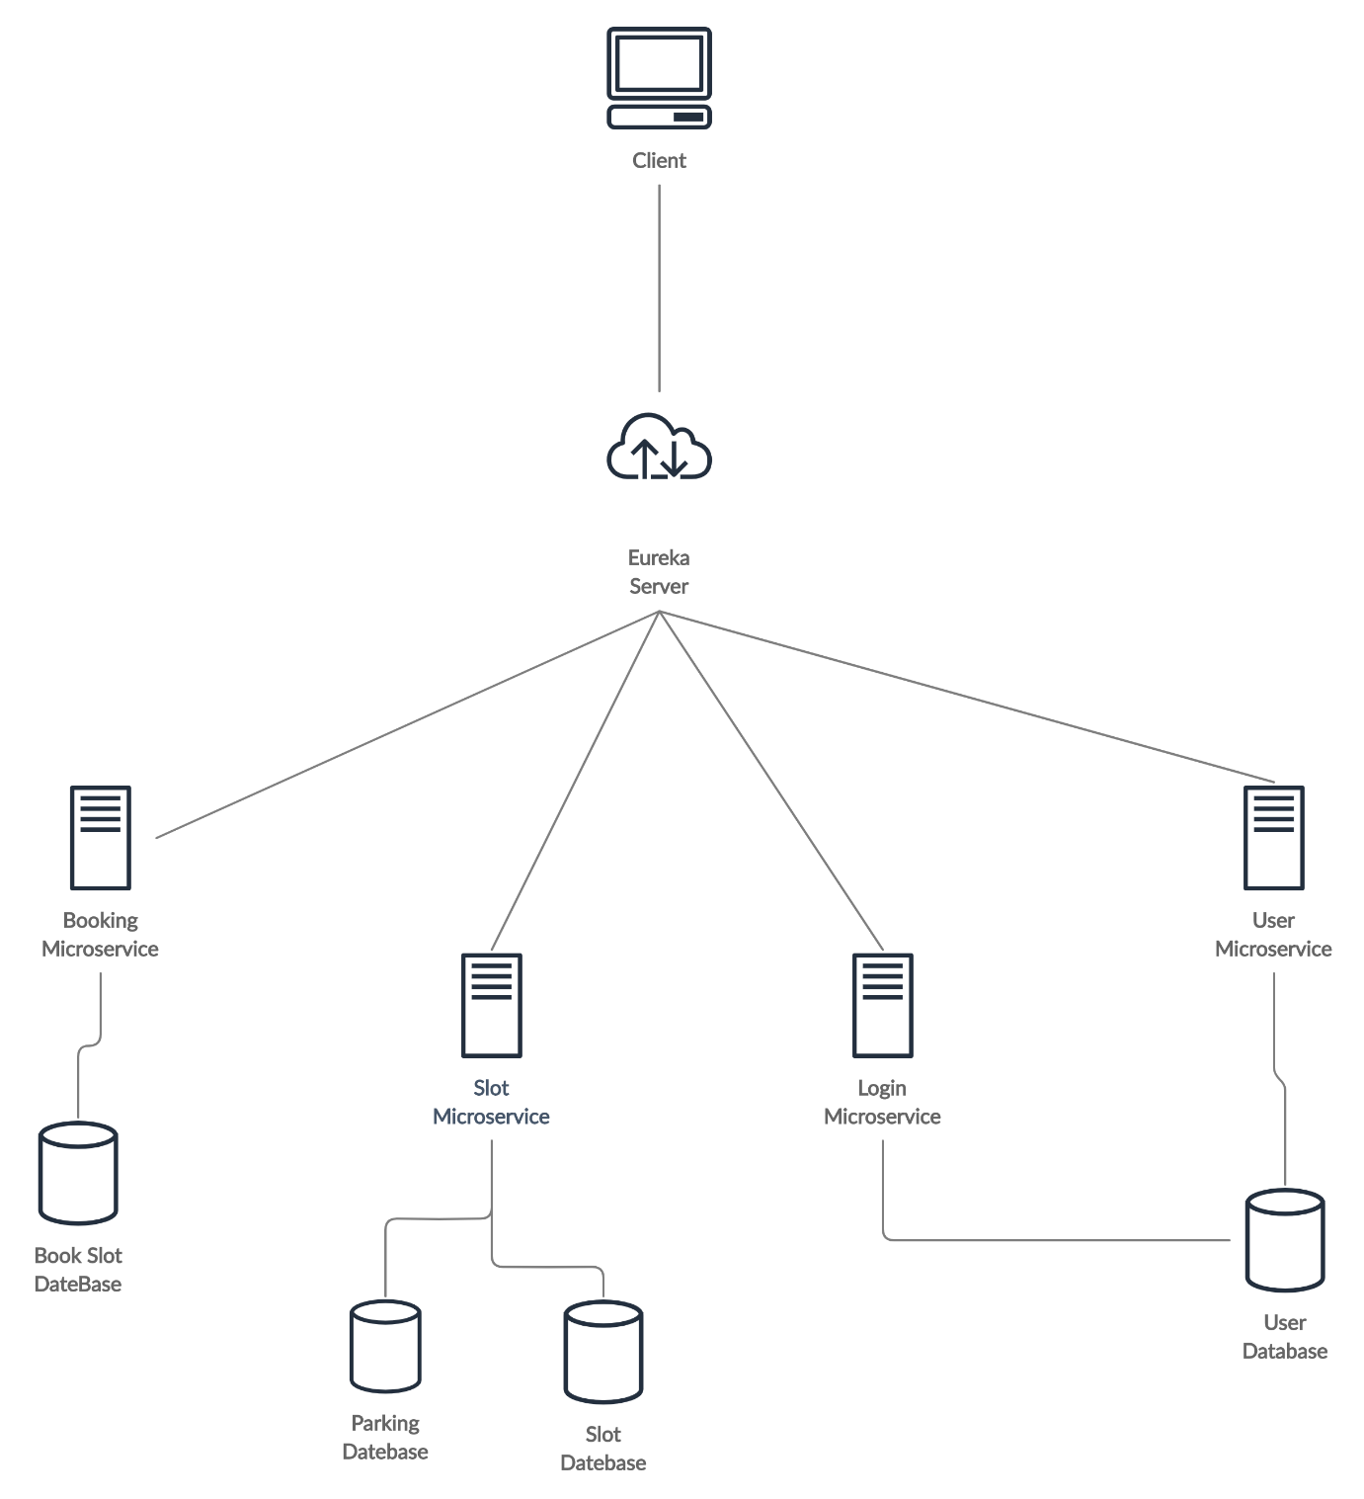

**Customer Micro service:**

Add User

Delete User

Check Role

Get All User

**Login Micro service:**

Validate Login.

**Slot Micro service:**

Add Parking

List All Parking

Update Parking

Delete Parking

Search Parking by Location

Search Slot by Location

Search Slot by Id

Search Slot by Location and Type

(Type = Two Wheeler or Four Wheeler)

**Book Slot Micro service:**

Book Slot

List All Booking

Search Booking by Username

Find Booking by Location